Pictures for Page1:
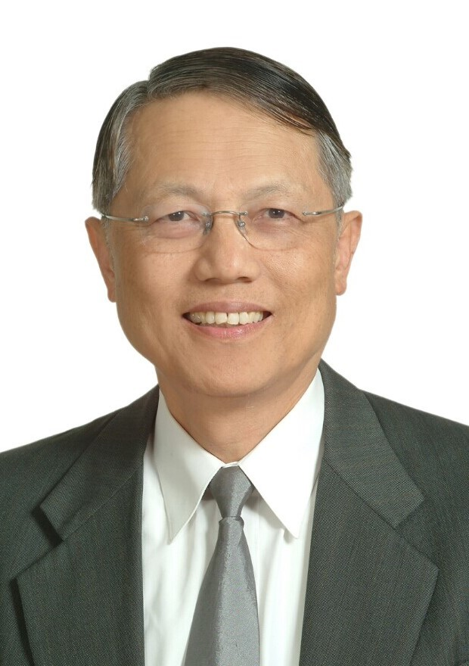
Picture 1

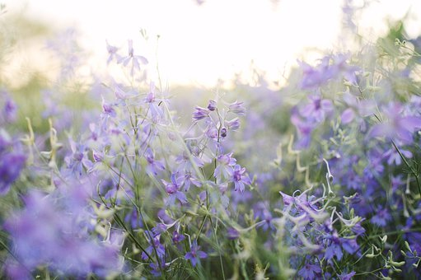
Pictire 2

Pictures for page 2:

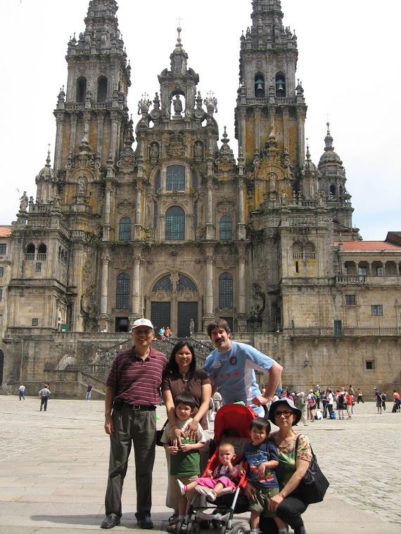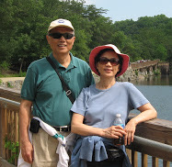
Picture 1 溫教授夫婦和女兒一家 溫教授伉儷

Picture for page 3:
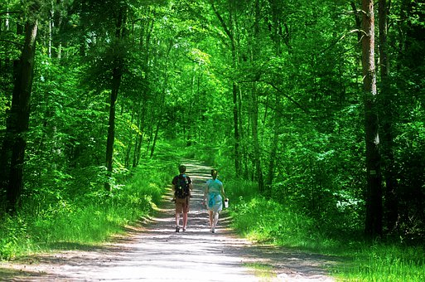

Picture for page 4:

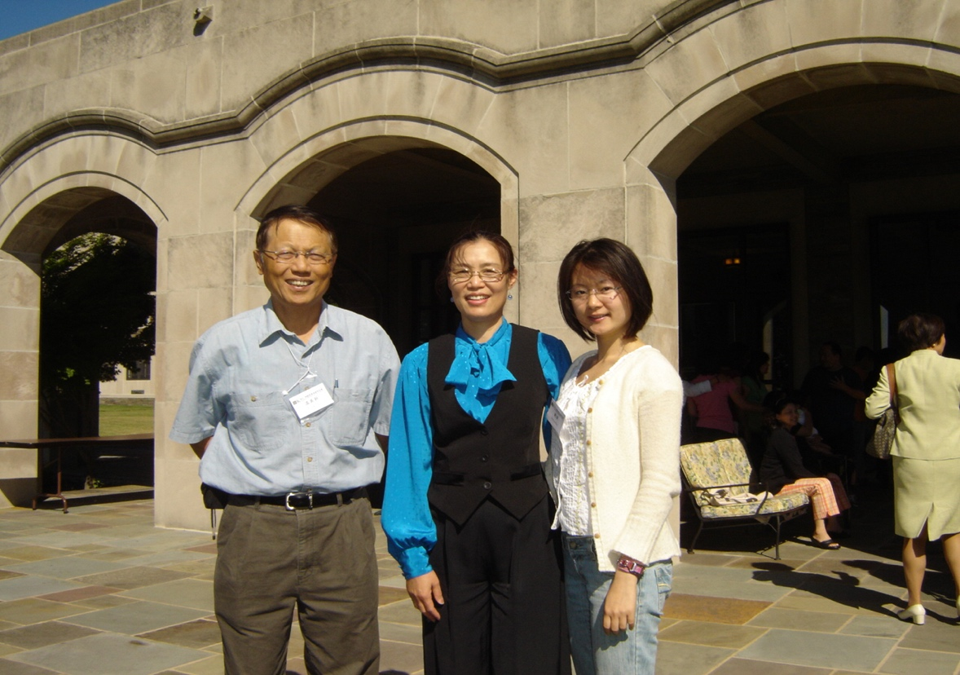
瑪利亞修道院，攜女兒與英幹兄在相聚與文化營（2007年）

Picture for page 5:

Picture for Page 6:
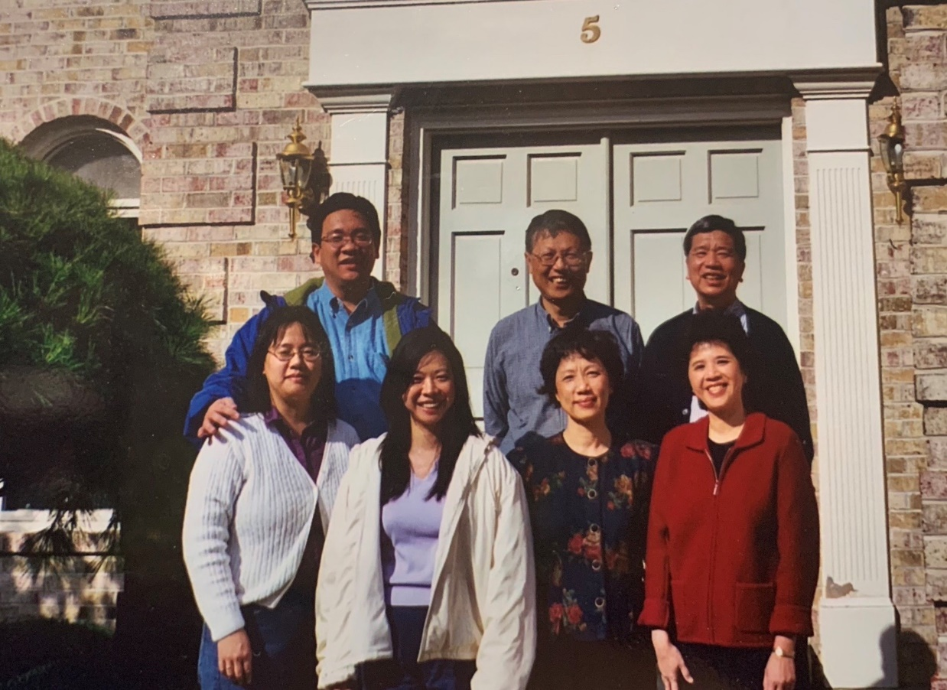
在溫教授家門口合照

Picture for page 7
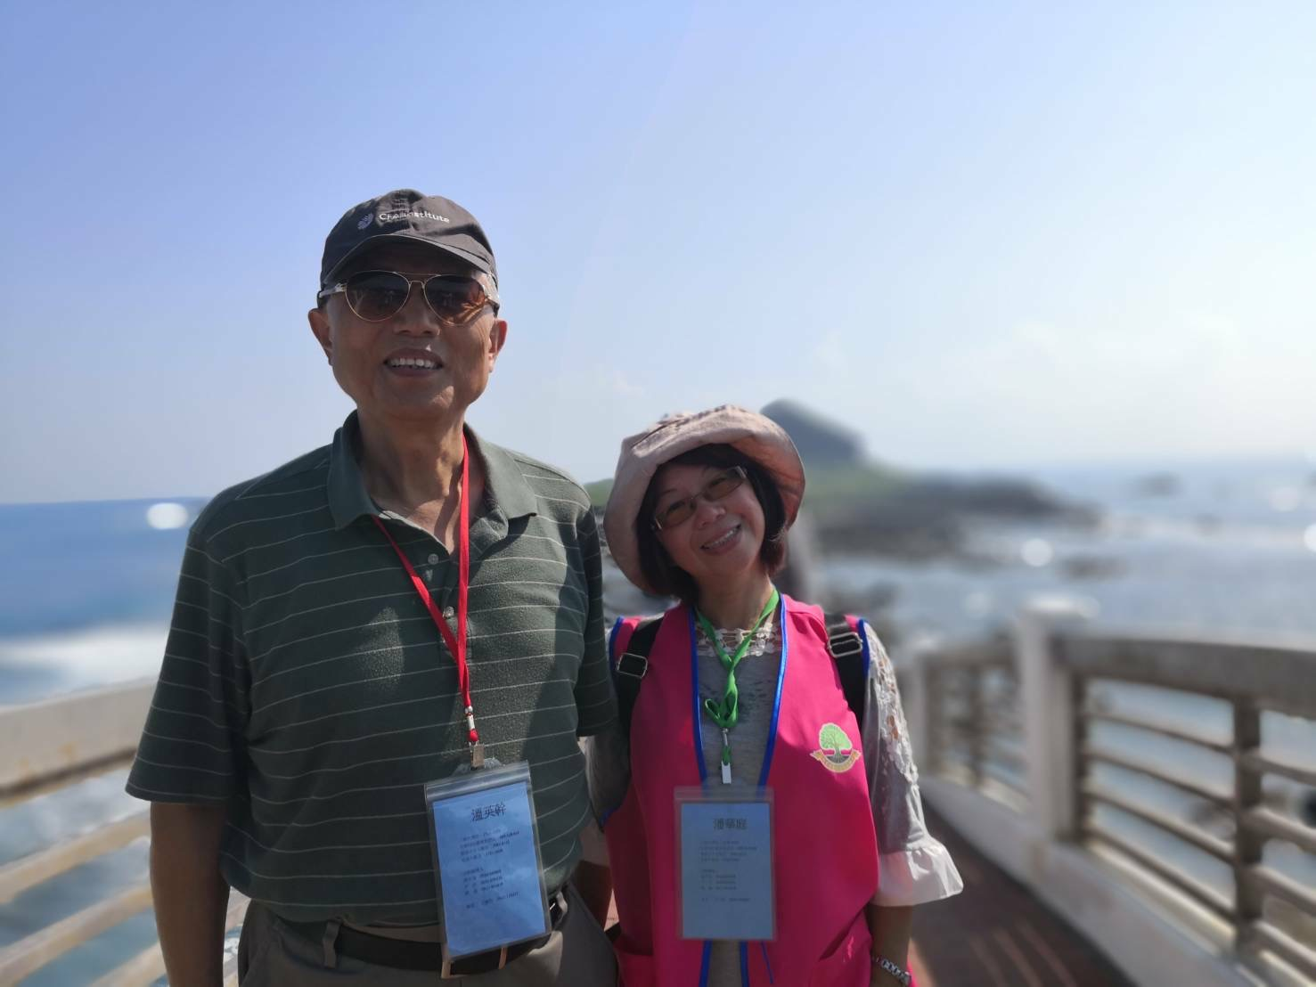

Pictures for page 8:
Picture 1:
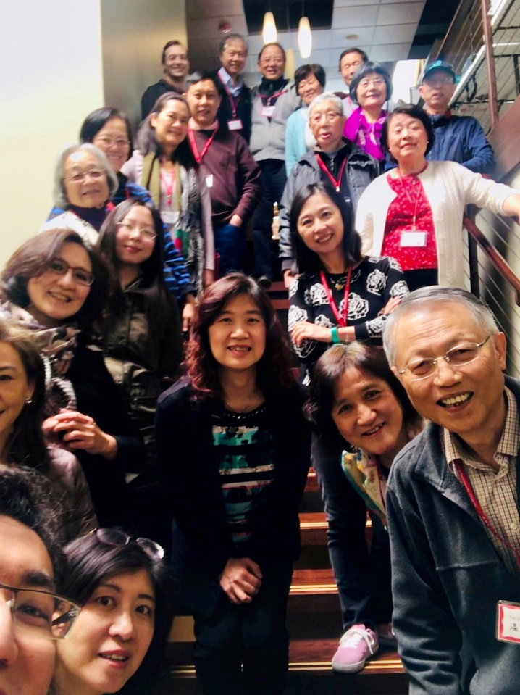

Picture of Linda Lin (section 3rd)
